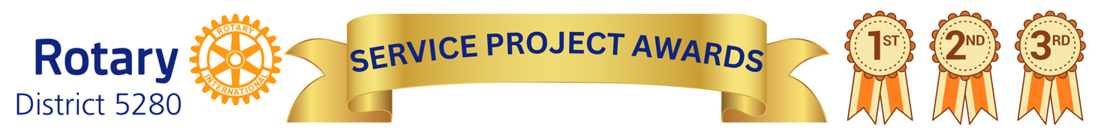
At this year’s District Conference (DisCon 2025), the District Leadership will be recognizing clubs for their most impactful service projects. This is your club’s chance to be celebrated for the meaningful work you do in your community!
Clubs are encouraged to submit multiple service projects for consideration—however, only one project per Area of Focus may be submitted.
This is more than just an awards opportunity—it’s a chance to showcase your club’s innovation and impact, and to inspire other clubs to implement similar projects in their own communities. After all, teamwork makes the dream work!

To submit a project, two things are required:
- Complete the official project application no later than May 28.
- Provide a visual display of your project to be showcased throughout the weekend at DisCon in Temecula. Poster boards must be self-standing tri-fold displays, or you may bring an easel for presentation.
Let’s celebrate service, share best practices, and lift each other up as we work together to make lasting change.
---------------------------------------------------------------------------------------------------------------
Club Name: ________________________________________________________________
Individual Completing Application: _____________________________________________
Individual Contact Information: ________________________________________________
Project Title: _______________________________________________________________
Date of Project Completion: ___________________________________________________
Which area of focus does this project fall under (check all that apply):
_____ Peacebuilding and conflict prevention
_____ Disease prevention and treatment
_____ Water, sanitation, and hygiene
_____ Maternal and child health
_____ Basic education and literacy
_____ Community economic development
_____ Environment
Provide a summary of the purpose of the project: ___________________________________
______________________________________________________________________________________________________________________________________________________

What did you do the identify the needs for this project?:
____________________________________________________________________________________________________________________________________________________________________________________________________________________________________________________________________________________________________________
Did you get an media recognition for this project?
____________________________________________________________________________________________________________________________________________________________________________________________________________________________________________________________________________________________________________

Did you get any new members because of this project?
____________________________________________________________________________________________________________________________________________________________________________________________________________________________________________________________________________________________________________

What other agencies were involved with this project?
____________________________________________________________________________________________________________________________________________________________________________________________________________________________________________________________________________________________________________

Any last comments to enhance your project?:
____________________________________________________________________________________________________________________________________________________________________________________________________________________________________________________________________________________________________________

